**EXPERIMENT 8**

**AIM**

Experiment to study Advanced shell script.

WRITE SHELL SCRIPT TO DISPLAY LIST OF USERS CURRENTLY LOGGED-IN,

DISPLAY TOP 10 PROCESSES IN DESCENDING ORDER OF CPU UTILIZATION AND DISPLAY

PROCESSES WITH HIGHEST MEMORY USAGE.

Code:

who

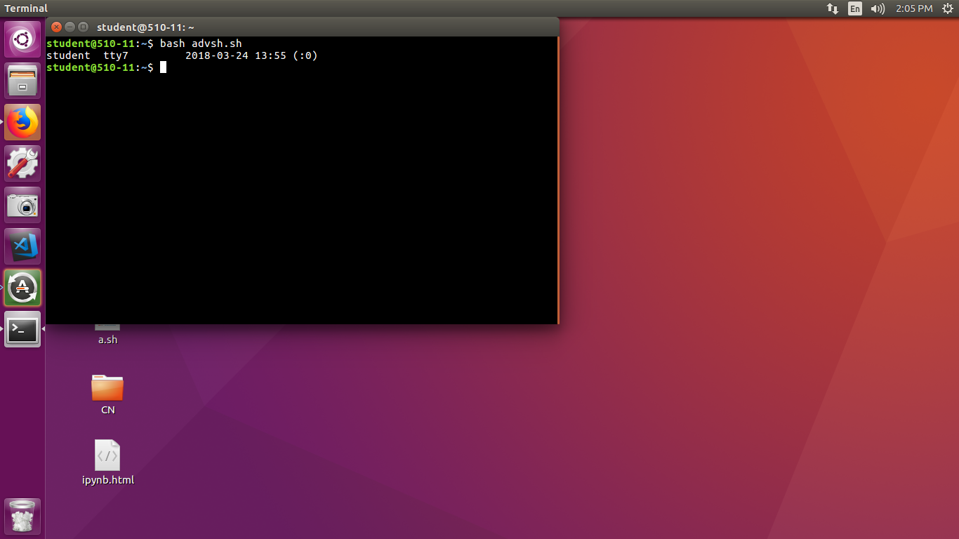

SHELL SCRIPT PROGRAM TO CHECK WHETHER GIVEN FILE IS A DIRECTORY OR NOT

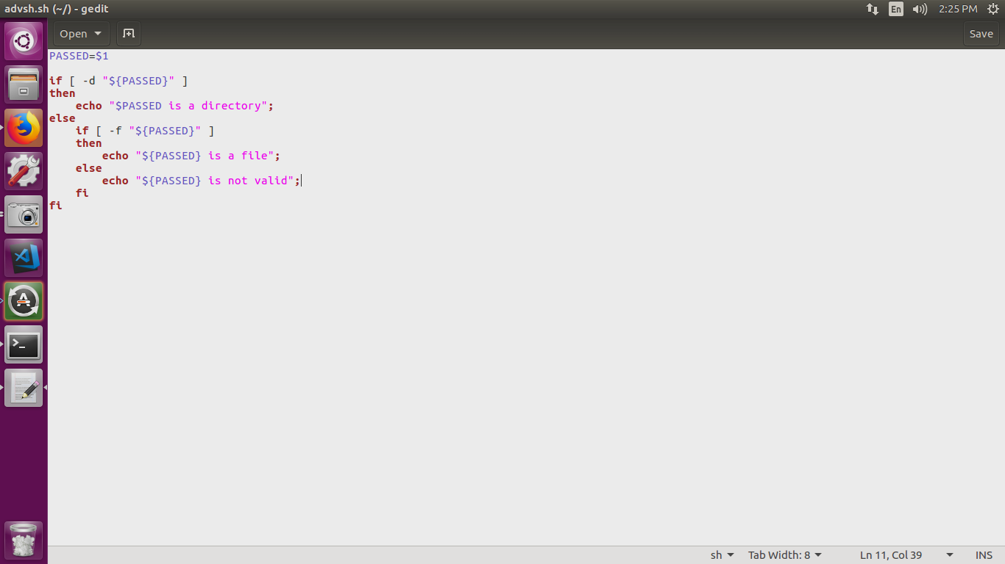

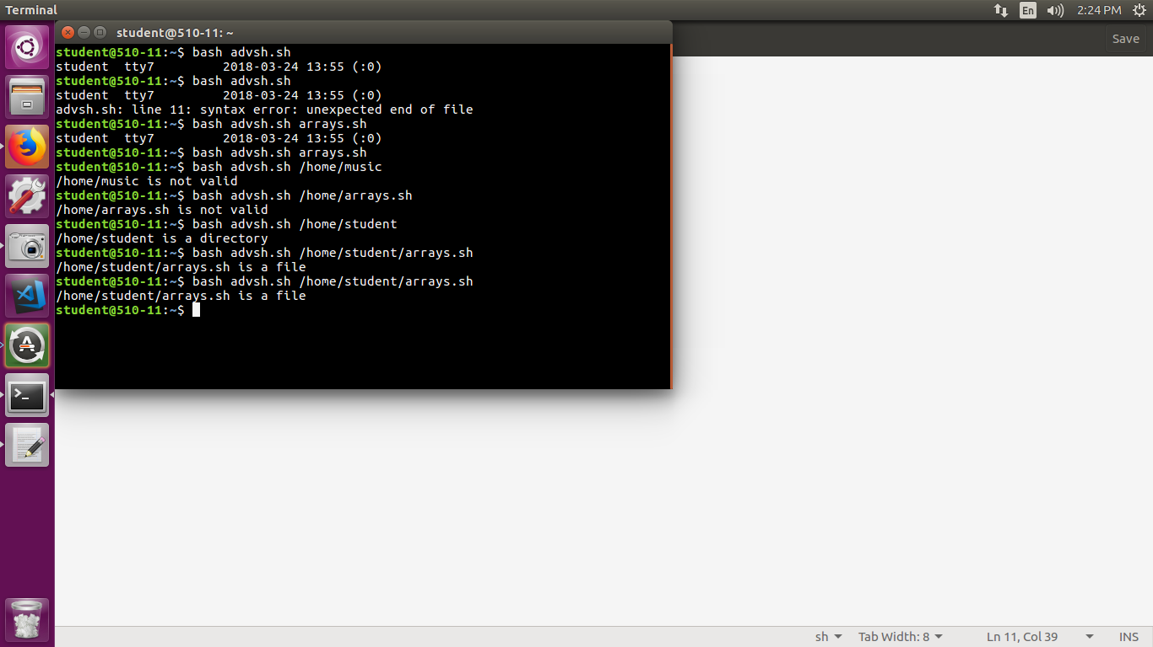

SHELL SCRIPT PROGRAM TO COUNT NUMBER OF FILES IN A DIRECTORY

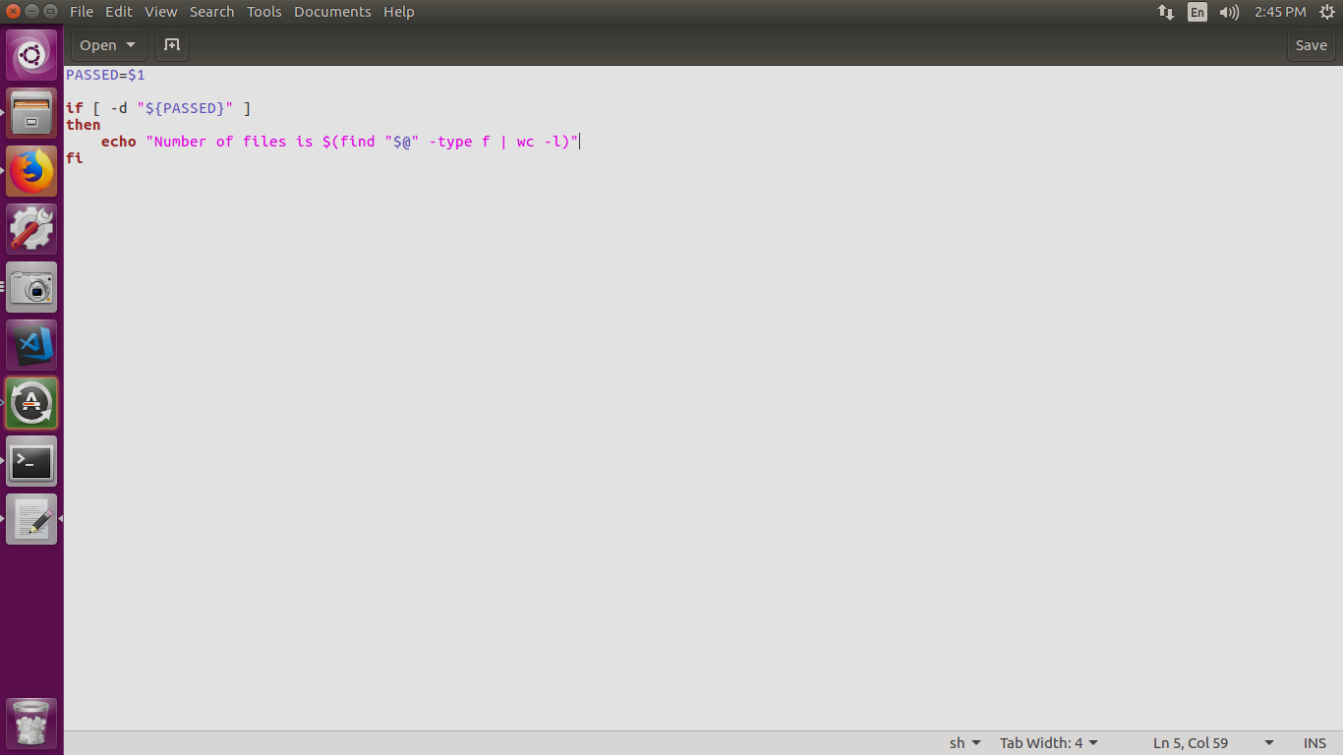

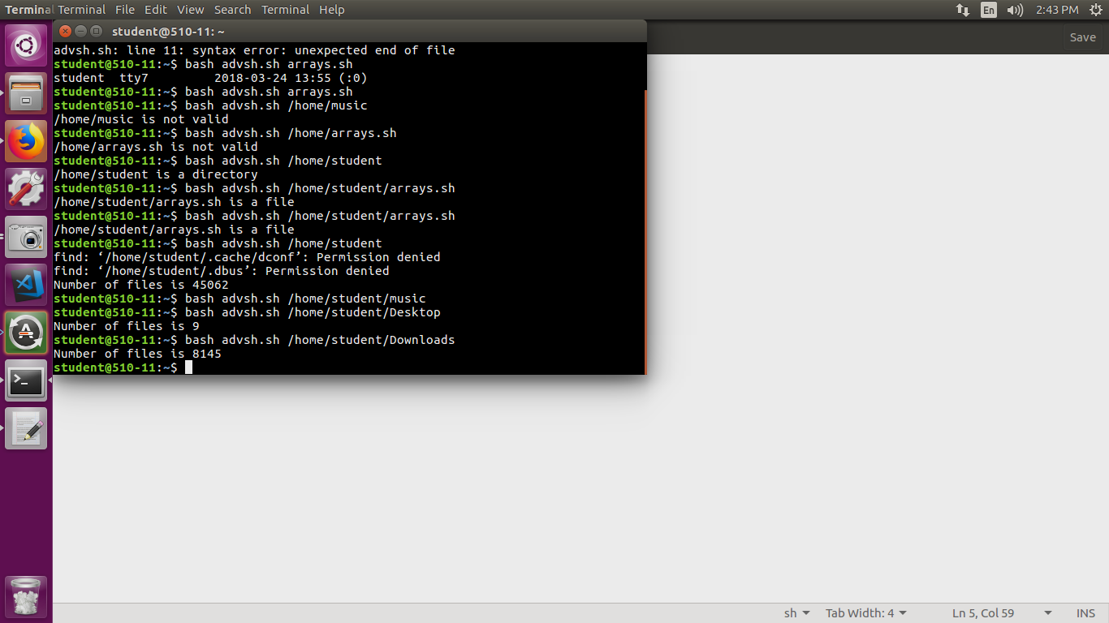

SHELL SCRIPT CODE TO COPY CONTENTS OF ONE FILE INTO ANOTHER

echo -n "Enter soruce file name : "

read src

echo -n "Enter target file name : "

read targ

if [ ! -f $src ]

then

echo "File $src does not exists"

exit 1

elif [ -f $targ ]

then

echo "File $targ exist, cannot overwrite"

exit 2

fi

# copy file

cp $src $targ

# store exit status of above cp command. It is use to

# determine if shell command operations is successful or not

status=$?

if [ $status -eq 0 ]

then

echo 'File copied successfully'

else

echo 'Problem copying file'

fi

OUTPUT

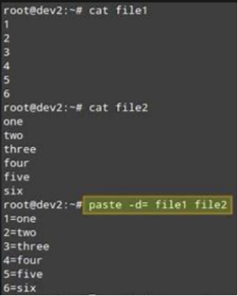

SHELL SCRIPT PROGRAM TO COUNT NO OF VOWELS,CHARACTERS,BLANK LINES AND

LINES

file=$1

v=0

if [ $# -ne 1 ]

then

echo "$0 fileName"

exit 1

fi

if [ ! -f $file ]

then

echo "$file not a file"

exit 2

fi

# read vowels

exec 3<&0

while read -n 1 c

do

l="$(echo $c | tr '[A-Z]' '[a-z]')"

[ "$l" == "a" -o "$l" == "e" -o "$l" == "i" -o "$l" == "o" -o "$l" == "u" ] && (( v++ )) || :

done < $file

echo "Vowels : $v"

echo "Characters : $(cat $file | wc -c)"

echo "Blank lines : $(grep -c '^$' $file)"

echo "Lines : $(cat $file|wc -l )"

OUTPUT

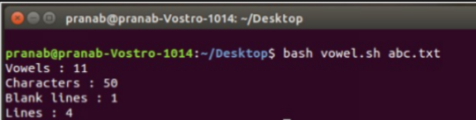

CONCLUSION

Thus, advanced shell scripts have been studied and executed.